Name: __________________________________________________________

Tuesday.
1.
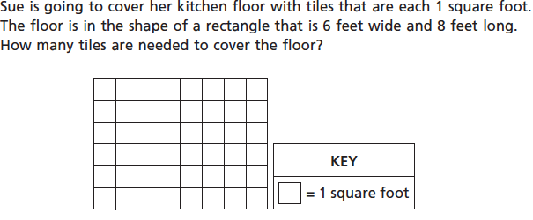Show your work and explain how you got your answer.

2. Jerome had 23 farm animal stickers and 17 sea animal stickers. Jerome used all of the stickers to fill an 8-page scrapbook. He put the same number of stickers on each page. How many stickers did he put on each page?
Show your work and explain how you got your answer.

3.
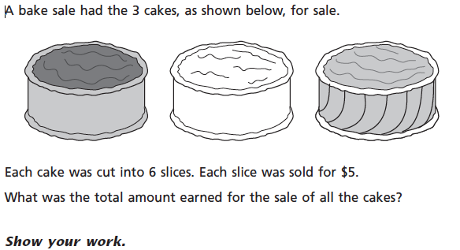

Wednesday

- Noel read 90 minutes each day for 6 days. Tyra read 60 minutes each day for 8 days. What is the difference, in minutes, between the total amount of time Noel read and the total amount of time Tyra read?
Show your work and explain how you got your answer.

2.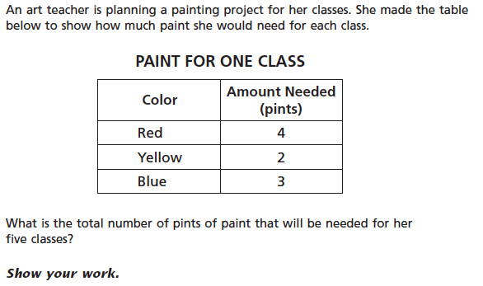

3.

Show your work and explain your thinking.

Thursday
1.
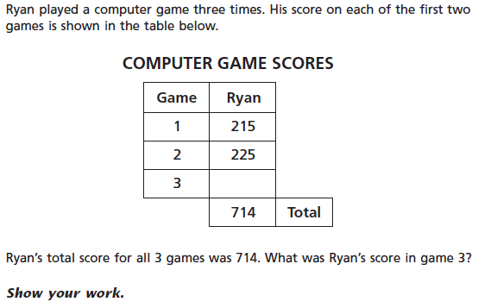

2.
Show your work and explain how you got your answer.

3.
Friday
1.
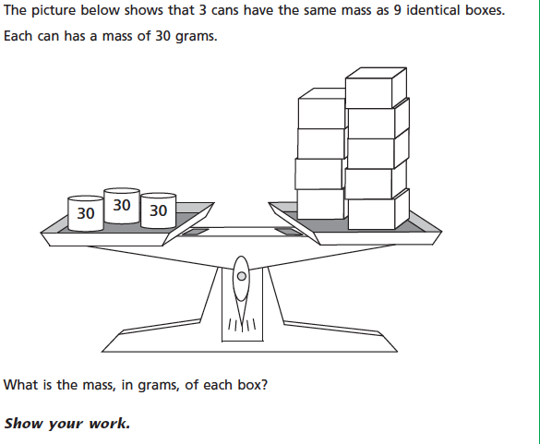
2.

Red beads __________________
Blue beads __________________

