Problem of the Night for Week of December 2-6, 2019
Name: ________________________________

Factoid: Flowers have a variety of color and smells. Flowers inherit these traits through genes. Just like flowers, the color of your eyes comes through genes!
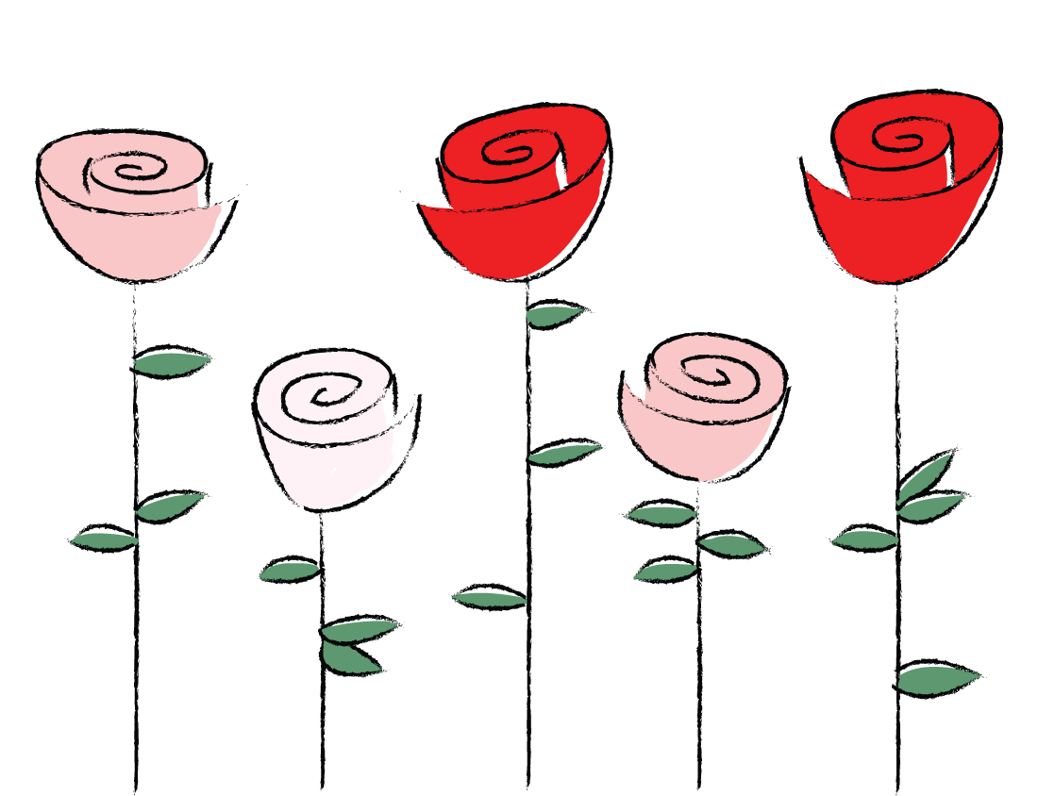
Use the chart to solve the problems below.
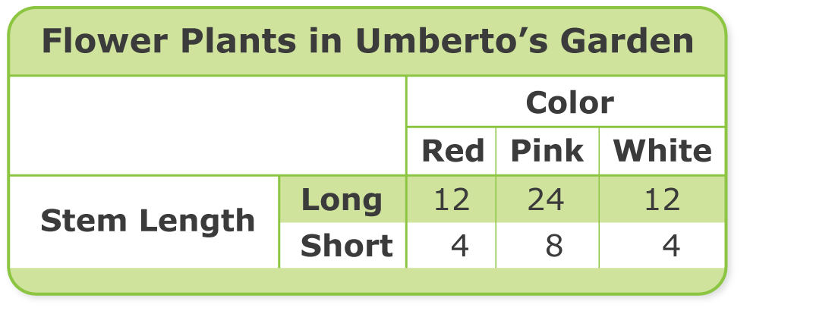

Monday Draw a Picture
Can Umberto share his long-stemmed white flower plants evenly among 3 beds?
Draw a picture to show why or why not.

Tuesday Use a Diagram
Umberto arranged the long-stemmed pink flower plants evenly into 4 beds. How many plants are in each bed? Draw a diagram and write an equation to show how to solve.

Wednesday Communicate Ideas
Write a division story for the equation below. Tell how to use repeated subtraction to solve. 24 ÷ 8 = ?

Thursday Extend Your Thinking
Umberto plants the red and pink long-stemmed flowers evenly in 4 rows. How many flowers are in each row? Tell how to find the answer.

Friday Extend Your Thinking
Write a fact family for the number of rows of short-stemmed flower plants there would be if Umberto put 8 plants in each row.

