Problem of the Night for Week of February 24-28, 2020
Name: ________________________________

Monday
- Last weekend Sanjay watched 3 television shows that were each 30 minutes long. He also watched 1 movie on television that was 90 minutes long. What is the total number of minutes Sanjay watched television last weekend? Show your work and explain your answer.

- Tayshawn sorts 56 marbles into equal groups with no marbles left over. Which statement could be true of the groups of marbles Tayshawn sorts? Explain your answer choice
- There are 6 groups of marbles with 8 marbles in each group.
- There are 7 groups of marbles with 7 marbles in each group.
- There are 8 groups of marbles with 7 marbles in each group.
- There are 9 groups of marbles with 6 marbles in each group.

- Patti puts 40 marbles in a bag. Each marble has a mass of 3 grams. What is the total mass of the bag of marbles? Show your work and explain your answer.

Tuesday

Part A:
A band has 36 members. They are arranged into 6 equal rows. How many band members are in each row? Show your work.

Part B:
Can the same 36 band members be placed into exactly 7 equal rows? Why or why not?
Explain your answer.

- The graph below shows the number of shirts of each color in a store. How many more red shirts than the total number of blue shirts and yellow shirts are in the store?
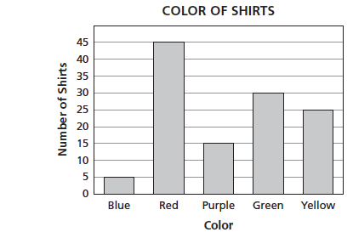
3.
Wednesday

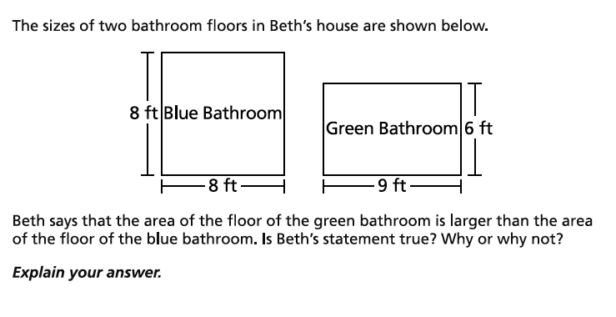

2.
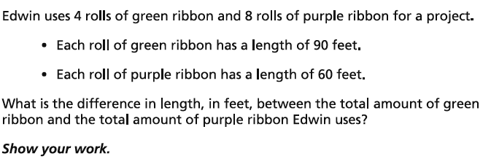

3.
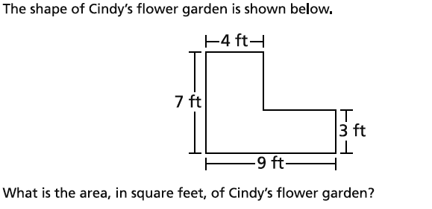

Thursday
1.
Show your work and explain your answer

2.
Explain how you arrive at your answer.

3.
The bar graph shows the numbers and colors of cars in a parking lot. The total number of silver and black cars equals the total number of red, white, and blue cars. How many black cars are in the parking lot? Explain your answer
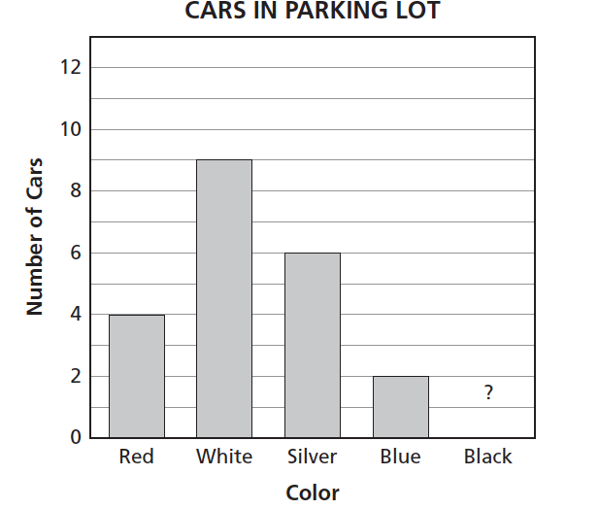

Friday

1.

2.
3.

