Problem of the Night for Week of January 27-31, 2020
Name: ________________________________

Mathematics Standards » Grade 3 » Measurement and Data

Represent and interpret data.
CCSS.MATH.CONTENT.3.MD.B.3:Draw a scaled picture graph and a scaled bar graph to represent a data set with several categories. Solve one- and two-step "how many more" and "how many less" problems using information presented in scaled bar graphs.

Factoid: “Blog” is short for “web log.” People publish blogs for a variety of reasons. Blog writing lets people connect with readers, can help businesses, or can simply be a hobby!

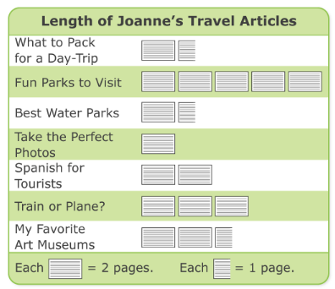

Monday Use a Diagram
How many pages is one of Joanne’s articles? Tell how you know.

Tuesday Explain
How many articles longer than 3 pages did Joanne write? Explain how to use a picture graph to tell.

Wednesday Use a Diagram
Draw a bar graph with the lengths of Joanne’s articles?

Thursday Use a Diagram
How much longer was Joanne’s longest article than her shortest one? Tell two different ways to find the answer.

Friday Extend Your Thinking
Joanne is paid $9 for each page that she writes. How much did she earn for these 7 articles? Tell how to find the answer.
Now write your own problem

Here are the Problems of the night. You may send an additional 1 or 2 problems along with these for homework each night. Sorry I didn’t get the time to make copies.

Thanks. Ms. Stampp

