Problem of the Night for Week of March 9-13, 2020
Name: ________________________________

Monday
- Gianna cuts a ribbon into equal pieces as shown below.
She uses 4 pieces of the ribbon for a project. What fraction of the ribbon does Gianna use for the project? Explain how you found your answer.

- Part A
Ms. Ross is making breakfast for her family. She makes 15 small pancakes to share equally among 3 people. How many small pancakes will each person get? Show your work and explain your answer.
Part B
Ms. Ross also wants to give each person a glass of orange juice. If each person gets 8 ounces, how many total ounces of orange juice does she need? Show your work and explain your answer.

3. Ashlynn rides her bike 2 miles to school and 2 miles home each day. How many total miles will
Ashlynn ride her bike to school and home in 40 days? Show your work and explain your answer.

Tuesday
- A store manager orders shirts from their warehouse. The shirts are packed into boxes and sent to the store, as described below. 81 shirts are ordered, and each shipping box holds 9 shirts.
How many shipping boxes are needed for all the shirts ordered?
Show your work and explain your answer.

- Wyatt wants to solve the equation below to find the missing factor.
8 x ___ = 24
How can Wyatt find the missing factor by changing the equation to a division problem?
Be sure to include the value of the missing factor in your answer.
Show your work and explain your answer.

- Which pizzas are cut into parts that are NOT equal? Explain.
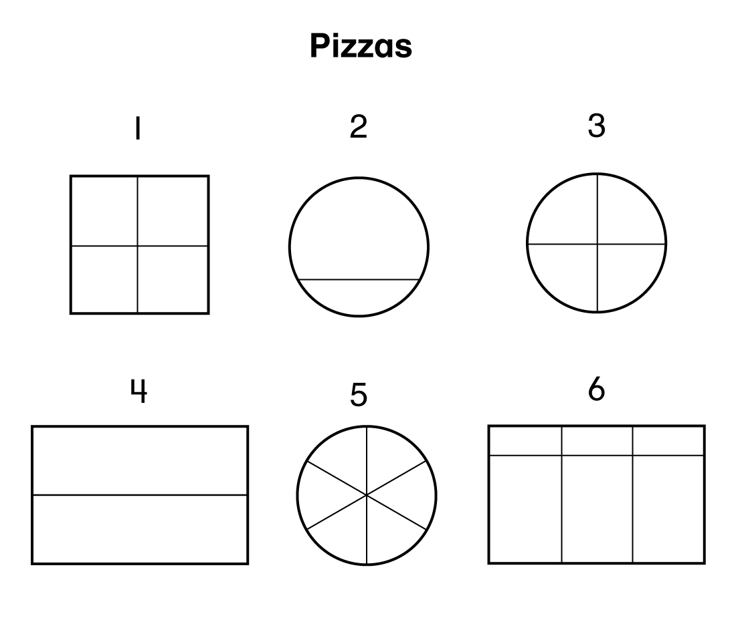
Wednesday
- Lucy is counting by 2s. She starts with the number 2 and stops at the number 50. Which number would Lucy not count? Explain how you got your answer.

- Coach Wu has a total of 30 soccer balls.
  - 9 soccer balls are white
  - the remaining soccer balls are one of three different colors (blue, pink, or green)
  - there is an equal number of blue, pink, and green balls
How many green soccer balls does Coach Wu have?
Show your work and explain your answer.

3. Which pizzas are cut into fourths? Explain.
Thursday

1. Jess scored 18 points during her last basketball game. Each basket she made was worth 2 points.
How many baskets did she make?

2. Leeza used unit squares to find the area of the rectangle shown below. What is the area in
square units, of the rectangle?
Key
= 1 square unit

3. Eric ate one slice of Pizza 5. He said that he ate 𝟣/8 of the pizza. Do you agree with Eric? Explain
Friday

Use the diagram to answer the questions below

.

- Which pizzas are divided into equal parts? For each of these pizzas, write the fraction that represents one part. Explain the answer you chose.

- Draw a pizza that is the same shape as Pizza 4. Draw lines to divide the pizza into 8 equal slices. What fraction represents 3 of the slices? Explain how you know.

