Problem of the Night Week of October 28, 2019
Name: ________________________________

Use the chart to solve the problems below.
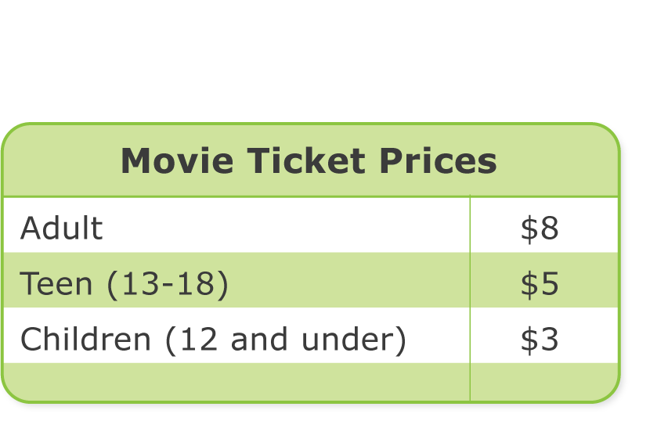

Monday Model
How much do 4 children’s tickets cost? Write an addition equation and a multiplication equation to show how to find the answer.

Tuesday Use a Diagram

3 teens went to the movies together. How much money did they spend in all? Draw a picture and write an equation to solve.

Wednesday Model

2 people of one age and 1 person of another age went to the movie. How much did they spend in all? Write equations to show how to solve.

Thursday Model

A family went to the movies together and bought 2 adult tickets, 1 teen ticket, and 2 children’s tickets. How much money did they spend in all? Write equations to show how to solve.

Friday Extend Your Thinking
2 groups of teens went to the movies. 1 group had 5 people and the other had 9. How much more did the larger group spend on tickets than the smaller group? Write equations to show how to solve.

